**Kathford International College of Engineering and Management Balkumari, Lalitpur, Nepal**



**A Final Year Project Proposal On**

**Xplitter- Expense Splitter**

**Submitted To**

Department of Computer Science and IT

Kathford International College of Engineering and Management

**In partial fulfilment of the requirement for the Bachelor Degree in Computer Science and Information Technology**

**Submitted By**

**Namkonghang Kirat (7329/072)**

**Neha Adhikari (7330/072)**

**Ruxana Maharjan (7342/072)**

**Srijal K.C. (7348/072)**

**March, 2019**

**ABSTRACT**

The project “Xplitter” is an android application which helps in splitting bills and expenses among a group of people. The app lets the user to register and login through their input credentials. After logging in, users are provided with a clean and simple GUI which lets them create a group and invite others or join into groups. The groups can be of 2 or more users. In the group, the members can update the transaction which will give notification to every members of the group. The transaction requires confirmation from at least 50% of the members to be a verified transaction. After the transaction is verified, notification is given to every member again. Each member in anytime can view how much amount s/he must pay or receive for the expenses to be splitted properly among the group members.

***Keyword: expense splitter, android application, groups, notification, transaction verification.***

**Table of Content**

1 Introduction 1

2 Problem statement 2

3 Project Objective 2

4 Literature Review 3

5 Methodology 4

5.1 Feasibility Study 4

5.2 Process Model 5

5.3 Tools 6

6 System Analysis 7

6.1 Use Case Diagram 7

6.2 Data Flow Diagram 9

6.2.1 Context Diagram 9

6.3 E-R Diagram 10

7 Testing and Verification 11

8 Timeline/Estimated Time Schedule 12

9 Expected Output 13

10 References 14

# 

# 1 Introduction

The project ‘Xplitter’ is the application developed for android based mobile systems. It is built for the purpose of splitting bills and expenses among a group of people.

The starting window of application provides an interface which asks user for registration for the app. Using the correct credentials, they can enter inside the app and performed the dedicated task. For sign up purpose, they can sign up using their respective Gmail. First, the app starts with no users list. Users can be added using other users email address that has been registered for the app. These users then can add each other to create a group of their own and can name their group. All the users that are added in a certain group can add the expense amount. So, users can create their group and simply input expenses that everyone has carried out and enter it into the app, and the app splits the amount everyone must pay or must receive by evenly splitting the expenses. Each member in group in anytime can view how much amount he/she must pay or receive for the expenses to be split properly among the group members through a sync process which requires internet connection. There is also a notification sent to each member for transactions made in a. For each change made by the group member of a group, the half of the other members of the same group should verify that the changes made in the expenses by ticking the “verify the changes made” option in their notification panel for it to be committed on the all members application. Multiple groups are also supported so that we can manage multiple shared expenses with different people.

The main goal of this project is to simply the splitting of the expenses and tracking the record properly. It prevents the paper work and makes the splitting fast and easy. Instead of writing stuff on paper and recalling who paid how much or who needs to pay whom, this process is automated by this application making this tedious process hassle-free, fast and accurate. Since system is being used for calculation, this ensures the accurate output more than that performed by the users using pen and papers which is an important aspect of any calculation. Hence this application provides the following advantages to is users:

* Avoid the paperwork and hassle calculations by making the system automatic.
* Fast calculation which saves their time.
* Accurate output ensuring the correct result.
* Easy to manage the multiple groups avoiding the confusions.
* Very easy to use because of simple user interface.
* Timely notification of each updates made so that everyone knows what is changed.
* Transparency of the expenses so that everyone knows nothing is hidden from them.
* Proper authentication and verification process so that other unwanted people/users cannot alter the data. Security is one of the major factors that is needed to be considered while developing any system.

# 2 Problem statement

Many people have faced the situation where they fail to accurately split bills when going out with friends or and remained at loss. Even if the expenses are tracked the calculation for splitting gets messy and everyone end up being confused.

‘Xplitter’ helps to solve the problem. It will divide the expenses and provides details to each person about ‘who paid how much’ and ‘who owes how much to whom along with who should pay to whom’. Hence the project ‘Xplitter’ is an android application which helps in splitting bills and expenses among a group of people and save people from messy calculation.

# 3 Project Objective

The objectives for developing Xplitter app are:

* To help in splitting bills and expenses among a group of people.
* To keep a proper track of who owes how much to whom.

# 4 Literature Review

There has been certain research conducted on similar project. However, it only had a plain interface with a very basic function [1]. There were no any methods by which we could verify the data changes and any users could just use it only in their device just like a regular calculator rather than making it a multi-user sync able application. There is no any notification mechanism [2]. So instead of making it a pure notepad like application which would only store certain transactions and show results by performing certain computation, the app provides more user friendly and secure with multiple functions added. Fair splitting will also be added. Using the proper back-end tool, much more features can be added so that better user experience can be obtained.

This project will further add features like adding image in each transactions, online payment method, and verification of each transaction by at least 50% of the group members.

# 

# 

# 

# 5 Methodology

Following methodologies are used:

* Feasibility Study
  + Description
  + Market feasibility
  + Technical feasibility
  + Financial feasibility
  + Legal Feasibility
  + Scheduling Feasibility
* Process Model Study
* Tools

## 5.1 Feasibility Study

Feasibility studies helps to determine how feasible our project is. Following feasibility study methods was conducted.

**5.1.1 Description**

The strategy for solving the problem stated is straight forward. First, an application that has a user-friendly interface will be created. Then the inputs from the user is taken and then the calculation is done within the application and the result is displayed in a proper self-explanatory way. This way, the work becomes hassle-free because the paper work is completely avoided, and the complex calculations are avoided in users head. For a better UX (User Experience), simple and easy to use UI has been decided which only includes the functions that the users require. For a proper security an authentication system will be added.

Since, abundant users use android phone, android application was decided so that the app can reach to as many users as possible.

**5.1.2 Market Feasibility**

Since, android platform has abundant user, an android application was decided so that it can reach to as many users as possible. The android phones are generally affordable and easy to use, which gives a promising present and future market in comparison to IOS/ Desktop platform. The users of the application can be anyone, it doesn't have a specific targeted user.

**5.1.3 Technical feasibility**

The application is technically feasible. The services will be provided through the application. The services that is intended to be provided are possible to be implemented using the available technology. Only an android device(phone) and an Internet is going to be needed. There is no any specific large hardware and software specification that is required to run our program. It can run in a minimal hardware. A general Android device is enough.

**5.1.4 Financial feasibility**

The startup capital needed is none. However, a working laptop is needed to write the code. All the software that are going to be used are open-source and free. So, with zero fund invested, this project can be created and be benefitted from it later on.

**5.1.5 Legal Feasibility**

The aspects of the proposed project do not conflict with the legal requirements like data protection acts, social media law etc.

**5.1.6 Scheduling Feasibility**

Hopefully the project will be completed fully in the given deadline.

## 5.2 Process Model

Process Model helps to determine the flow of how the project will be completed. For the early development of this application, Agile SDLC Model will be. The reasons for choosing this model is because:

* It suits small-medium size project, with rapidly changes in the requirements as customer is involved during each phase.
* Very limited planning is required to get started with the project. It helps the company in saving time and money.
* Fast release of the first product version.
* Risk are minimized because of flexible change process.
* Project are divided by short and transparent iterations.

However, later during the project development the model might be changed according to the need.

## 5.3 Tools

The following tools were decided to be used for the project:

Workplace:

* Android Studio IDE

Front-end Tool:

* XML

Back-end Tool:

* Java

Other Tools:

* Microsoft Visio 2010
* Google Docs

# 6 System Analysis

# System analysis was done in order to completely understand the application that will be developed. The gathered information will help to create logical models so that we can code the application to satisfy our goals. The large complex project was broken into small manageable parts so each may be designed, studied and analyzed in detail. The tools used will help to transform requirement specification into implementation. UML has been used as visual modeling language. Some of the tools used are Use case diagram for analyzing functional requirement, ER diagram for data modeling technique and Context diagram for process modeling.

## 6.1 Use Case Diagram

It provides concise summary of what the app should do at abstract level. The expected behavior of the app has been specified. Here, Xplitter-Expense Splitter Application is an app that will be developed. User and system admin are actor that will use the app. There are list of use cases that captures the requirements that the actors want to achieve. User being in the left is the primary actor who initiates the use of the app. System admin being at right is the secondary actor who reacts only when user does something like here when user login, system admin authenticates.

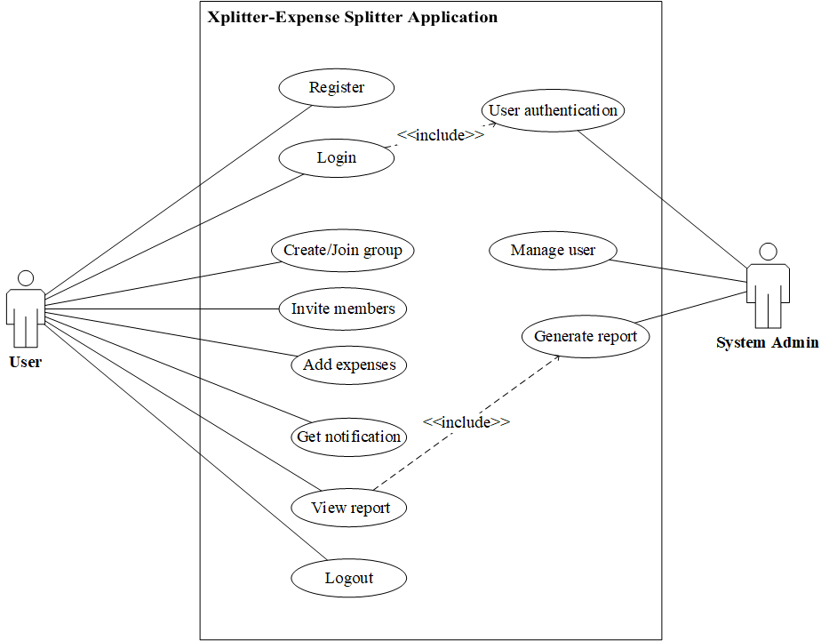

**Fig 6.1: Use Case Diagram for Xplitter Application.**

## 6.2 Data Flow Diagram

## 6.2.1 Context Diagram

Gane Sarson notation is used for drawing Context Diagram. The context diagram below is the overview of App i.e. the expected input and output of App. Here, the external entity User will receive information from app and also contribute into the app. Using this context diagram, the expected data that will go into App and the data that will be returned to external entity after input is processed by the app is modeled. So here, User and System Admin is the external entity who will input data into the app. After these entered data is processed by App, the output is returned to the external entities.

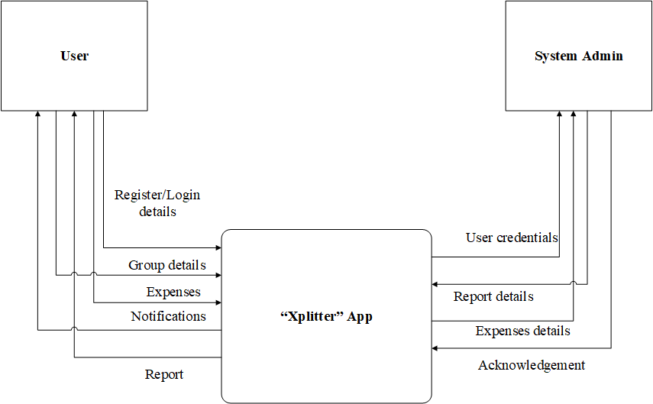

**Fig 6.2.1: Context Diagram for Xplitter Application**

## 6.3 E-R Diagram

Chen’s Notation is used to draw the ER diagram. Constructing ER diagram helped us to visualize the database for the App. The entities are User, Groups, Expenses and Notification which will be the tables in database in order to store data. Their attributes are the properties that will describe the entities i.e. the columns of table that is needed to describe each tables and relationship between entities are showing how these entities or tables in database will be linked together.

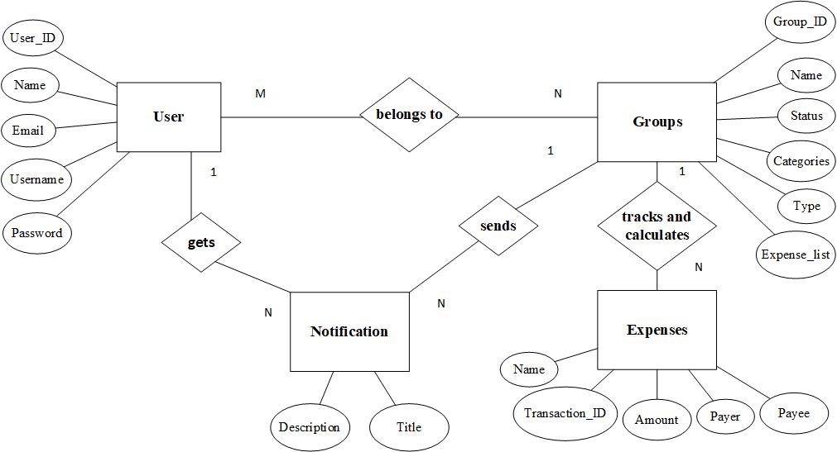

**Fig 6.3: Entity Relationship Diagram for Xplitter Application.**

# 7 Testing and Verification

After the development of any application, it is very important to insure the dedicated application produces the expected output. It should run as it was meant to run. Any error, bugs or false result is not acceptable while deploying the software because it might cause the failure of the application. Hence, certain important testing of the application was planned to be performed before deploying it. Certain testing that will be performed are:

* Alpha Testing
* Beta Testing
* Back-end Testing
* Functional Testing
* Compatibility Testing
* Happy Path Testing
* Monkey Testing

The application will be verified to make sure that the product has been designed to deliver all functionality to the customer. Verification at the starting phase of development also helps in understanding the product better.

# 8 Timeline/Estimated Time Schedule

The total duration of the project will be nearly about of 4 months. This includes all the activities and the estimated time duration required to develop the project. The estimated timeline of the project is represented in the Gantt chart below:

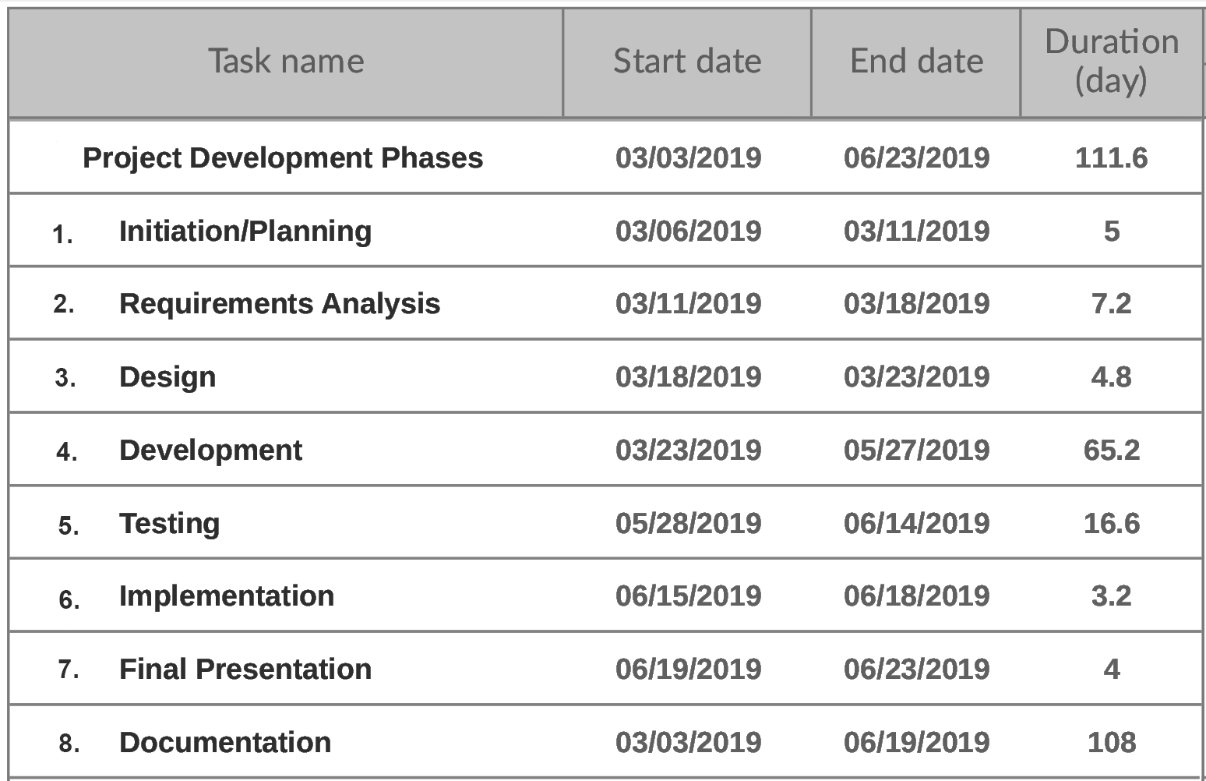

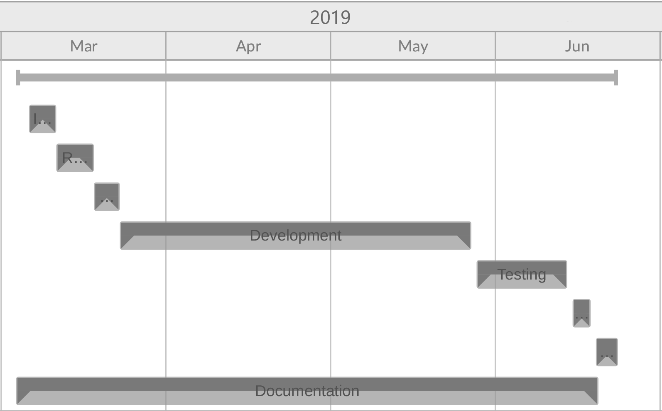

# 9 Expected Output

The expected outputs of our application are as follows:

1. Users will be able to register and login to their account.
2. Users will be able to create or join groups.
3. Users will be able to input transactions in the group and verify it.
4. The application will notify and alert the users on new transactions added.
5. The application will be able to compute the input data and provide the users with expected information which may be amounted to pay or receive.
6. The application will be able to provide interactive and reactive GUI.

# 10 References

[1] 6 February, 2019. “Group Expense – track & split expenses”. [Online]. Available: <https://play.google.com/store/apps/details?id=com.expensecount.groupExpense&hl=enhttps://play.google.com/store/apps/details?id=com.expensecount.groupExpense&hl=en>

[2] “Android Group Expense Tracker Application”. [Online].Available: <https://nevonprojects.com/android-group-expense-tracker-application>/